BSP - Implementation Guide

mFRR energy activation market

Business process: mFRR energy activation market
Version: 1.1.1
Status: Published
Date: 9.9.2021
  - Revision History
Version | Date | Changed by | Comments
1.0 | 17.12.2020 | Nordic mFRR EAM project | First published version of the guide
1.1 | 14.06.2021 | Nordic mFRR EAM project | Added:  National bid attributes and products:  - Faster activation and earlier deactivation  - InclusiveBids  - Period shift activation  - Slower product bids (specific product)  New documents:  - Bid availability document  - Reserve allocation result document  - Acknowledgement document  Updated/added:  - Conditional linking  - Activation heartbeat description  - General rules for messaging  - TSO specific: implementation plans  - TSO specific: alternative channels
1.1.1 | 9.9.2021 | Nordic mFRR EAM project | Updated:  - Small modification of "Update and cancellation principles"  - Validation rule for not allowing change of bid period and resource object  - Adjusted description of 3.4 Activate bid process  - Codes for type and processtype to Acknowledgement document  - Document codes, and naming of document time interval attribute for Activation document  - Reason codes for ReserveBid document and ReserveAllocationResult document  - Implementation plan Svk and SN: removed pilot

Table of contents:
1 Introduction 5
1.1 Background and overall Nordic implementation plan 5
1.2 Scope 6
1.3 Terms and definitions 7
1.4 References 8
2 Business context 9
2.1 Overall process and timeline 9
2.2 System context 10
2.3 Fallback 11
3 Business process 12
3.1 mFRR Business process 12
3.2 The mFRR energy activation market sequence diagram 13
3.3 Submit bid process 14
3.4 Activate bid process 19
3.5 Publication and reporting of market results 20
4 TSO specific information 22
4.1 Energinet 22
4.2 Implementation plan 22
4.3 Fingrid 24
4.4 Statnett 26
4.5 Svenska kraftnät 29
5 General rules for messaging 31
5.1 Date and time 31
5.2 Document coverage 31
5.3 Daylight saving time 31
5.4 Unique identifiers - UUID 31
5.5 Document identification and revision number 31
5.6 Update and cancellation principles 31
5.7 Acknowledgment 32
5.8 Energy communication platform 32
6 Appendix 1 – Document attributes and dependencies 33
6.1 Bid document – Attributes and dependencies 33
6.2 Activation document – Attributes and dependencies 41
6.3 Bid availability document – Attributes and dependencies 45
6.4 Reserve allocation result document – Attributes and dependencies 47
6.5 Acknowledgement document – Attributes and dependencies 52
6.6 Supported coding schemes for sender/receiver identification 53
7 Appendix 2 – Examples 54

Introduction
This implementation guide describes the interface between BSP and TSO for the mFRR energy activation market. The guide (v0.9) will be updated based on feedback from the market participants and reassessment of the TSO's implementation plans.

Background and overall Nordic implementation plan
mFRR Energy activation market (mFRR EAM) is a project within Nordic Balancing Model (NBM) program. NBM is the program for updating the Nordic balancing process in order to facilitate increased volumes of variable renewable energy in the system, European market integration and improved balancing market efficiency, while maintaining operational security in the most cost-effective manner. This is a complex program having several great challenges to be resolved, including changing and automating critical system operation processes.
The mFRR EAM will go through 4 development steps from now until the Nordic TSOs are connected to the European platform for mFRR activation (MARI).
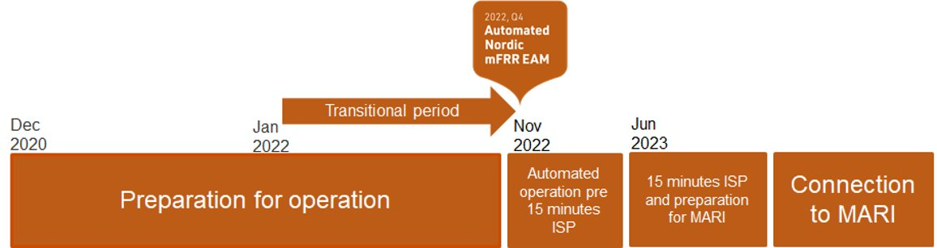

The steps are:
- Preparation for automated operation (from now and to Q4 2022)
- In the TSO control centres there will be focus on testing and training. New IT tools, new roles and routines and fall-back solutions will be developed and introduced to the operators.
- For BSPs the main changes are the introduction of new bid format and attributes and changes to electronic ordering. Details for these changes are described in this implementation guide.
- Automated operation pre 15-minute ISP (from Q4 2022 to Q2 2023)
- New business/operation model with automatic balancing solutions, but still 60-minute ISP. The purpose of this step is to give time for new processes, organization and IT-systems to be used, adjusted and verified, before go-live of 15 min ISP and MTU.
- All activation processes planned for step 3 will be supported. In this step the scheduled mFRR activation process is running every 15 minutes.
- The BSPs must use the new CIM-based formats and can use new attributes for bids. The BSPs must be prepared for different activation dynamics than today. Statnett and Svenska kraftnät will develop a period shift process to replace the current products produksjonsflytting (SN) and kvartsaffär (Svk).
- 15-minute ISP and preparation for MARI (from Q2 2023)
- When entering this step, the ISP and MTU change to 15-minute resolution. Nordics are now also fully mACE based regarding mFRR balancing. The control centres are now dependent on the new IT-solutions, including new fall-back processes and solutions
- Period shift product functionality is still running (in Norway and Sweden) but after a settling period it will be reassessed if this is still needed.
- Connection to European mFRR platform (MARI) (go-live is not planned)
- Move from Nordic platform the European platform for mFRR (no changes for BSPs)
- Standard mFRR product shall be fully implemented

On the NBM web-page the Nordic TSOs has published "Memo - Process for activating products" Ref [10]. The memo describes the stepwise implementation of different market rules for submitting and activating bids, including product attributes and characteristics. Some of the market features may vary between TSOs and might still be under assessment. Such assessments, including discussion with BSPs, will be part of each TSOs process for updating Terms and Conditions and other relevant regulations/documentations.
Specific implementation plans for each TSO for the processes described in this implementation guide are described in chapter 4 "TSO specific information".

Scope
This document covers the implementation of Nordic mFRR energy activation market and provides information about the processes required to support this market. Both functional and technical aspects are covered. The intended users of this document are the participating BSPs.
The main processes described are:
- Bid collection process, including
- New CIM-based message format
- New bid attributes
- Energy activation process
- New/changed activation processes: Scheduled activation, Direct activation, and (for Norway and Sweden) Period shift process
- Changes to electronic ordering, including introduction of activation heartbeat

Terms and definitions
Acronym | Term | Definition
AOF | Activation Optimization Function | The role to operate the algorithm applied for the optimisation of the activation of Balancing Energy bids within a Coordinated Balancing Area.
BEGCT  (BSP GCT) | Balancing Energy Gate closure time | The point in time when submission or update of a balancing energy bid is no longer permitted
BEGOT | Balancing Energy Gate opening time | The first point in time when submission of a balancing energy bid is permitted
BRP | Balance Responsible Party | A market participant or its chosen representative responsible for its imbalances
BSP | Balancing Services Provider | A market participant with reserve-providing units or reserve-providing groups able to provide balancing services to TSOs
CIM | IEC Common Information Model | A standard for describing information about an electrical network. The European style market profile is a profile derivation from the CIM to harmonize the energy market data exchanges in Europe.
CZC | Cross Zonal Capacity | The cross-zonal transmission capacity between two bidding zones
DA | Direct activation / direct activatable bid | Activation of standard mFRR product bid(s) at any point of time following the point of scheduled activation of the quarter hour and until the point of scheduled activation of the subsequent quarter hour.
FAT | Full Activation Time | The period between the activation request by the connecting TSO and the corresponding full delivery of the concerned product
ECP | Energy Communication Platform | Reference implementation of MADES standard
ISP | Imbalance Settlement Period | The time unit for which balance responsible parties' imbalance is calculated
MADES | Market Data Exchange Standard | Communication IEC standard designed by ENTSO-E
MOL | Merit Order List | A list of balancing energy bids sorted in order of their bid prices, used for the activation of those bids
MTU | Market Time Unit | The period for which the market price is established or the shortest possible common time period for the two bidding zones, if their market time units are different.
SA | Scheduled activation / schedule activatable bid | Activation of standard mFRR product bids at a specific point in time with respect to the period of time for which the bids were submitted. The scheduled activation time is once per quarter hour.
TSO | Transmission System Operator | A party that is responsible for a stable power system operation (including the organisation of physical balance) through a transmission grid in a geographical area. In the Nordic synchronous area, there are four TSOs: Svenska kraftnät, Fingrid, Energinet.dk and Statnett.
 | Connecting TSO | the TSO that operates the scheduling area in which balancing service providers and balance responsible parties shall be compliant with the terms and conditions related to balancing;
TSO GCT | TSO energy bid submission gate closure time | The latest point in time when a connecting TSO can forward the balancing energy bids received from a balancing service provider to the activation optimisation function

References
- mFRR Implementation Framework https://consultations.entsoe.eu/markets/mfrr_implementation_framework/
- Common Information Model (CIM) and CIM based documents. ENTSO-E implementation guides, see ENTSO-E Electronic Data Interchange (EDI) Library
- Acknowledgement: IEC 62325-451-1: Acknowledgement Business Process And Contextual Model For CIM European Market.
- EIC codes: The Energy Identification Coding (EIC)
- ENTSO-E codelist: Common information model (CIM) European style market profile
- European platform - MARI : Manually Activated Reserves Initiative (entsoe.eu)
- Nordic Trading System BRS: This document is a Business Requirement Specification (BRS) detailing the document exchanges related to trade in the Nordic energy market
- Nordic Operate BRS: This document is a Business Requirement Specification (BRS) detailing the document exchanges related to operation of the Nordic energy market.
- NMEG Code List Library: Description of additional codes used for the Nordic Market, Code list schema.
- Nordic TSOs - Memo - Process for activating products

Business context

Overall process and timeline
In the figure below the timing for the bidding and activation processes is illustrated. The subprocesses and timing where the BSP is involved are indicated in orange colour.
Delivery period

AOF result
TSO
bid
GCT
BSP
activation
mFRR
Request
and ATC
BSP
bid
GCT
Standard
product
definition
Fully
activated
Activate bids
Submit bids
cation
Filter bids
Select bids
Verify
The timing of the processes will change through the four development steps described in chapter 1.1. The planned timing for each development step is described in the table below.
In the "Automated operation pre 15-min ISP" phase, the TSOs will have some more time from bids are selected by the Activation Optimization Function (AOF) to the activation is electronically ordered, than in later steps. The reason for this is to make it possible for the TSOs to initiate remedial actions before activation start, to avoid potential congestions. During "Automated operation pre 15-min ISP" the TSOs will be able to assess and adjust congestion management functionality, before go-live of 15 min ISP.
Timing in minutes relative to the start of the delivery period | Today | Automated operation, pre 15-min ISP | After 15 min ISP but before connection to MARI | When connecting to MARI
BSP GCT (BEGCT bids) | 45 *) | 45 *) | 25 | 25
TSO GCT | 45 *) | 17 | 12 | 12
TSO mFRR request | NA | 15 | 10 | 10
AOF run | NA | 15 | 10 | 10
AOF results | NA | 13 | 8 | 8
TSO verification period
Activation orders are sent to BSPs | NA | 7.5 | 7.5 | 7.5
Full Activation Time, FAT (minutes) | 15 | 15 | 12.5 | 12.5
*) relative to the hour to which the delivery period belongs

System context
The diagram below shows the system context of the mFRR energy activation market from a BSP viewpoint. This document provides detailed information about the message exchanges between BSP and TSO. The other exchanges are shown for information purposes only and are outside the scope of this document
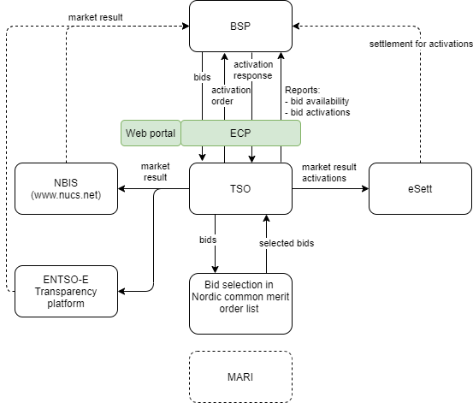

Fallback

Bid collection
Each TSO will have redundant mechanisms to receive bids from BSPs. In addition to machine-to-machine via ECP, it could be a web solution, e-mail, etc. See more on the TSO specific details in chapter 4.

Bid selection
In cases where the automatic solutions don't work, there will be fall-back solutions in use by one or more TSOs. This fall-back algorithm does not take all bid attributes into account and cannot guarantee a bid selection where all bids that are in-the-money are selected (e.g. not selecting up regulation bid with lower bid price than the marginal price). Unforeseeably rejected bids can potentially happen in normal operation but is more likely to happen in fall-back situations.

Activation
Each TSO will have a redundant mechanism to order bid activation. TSO specific details on the redundancy mechanism and handling of issues with communication with BSPs are described in chapter 4.

Business process
This chapter describes the mFRR EAM process from a BSP perspective with a focus on implementation of message exchanges. In addition to this implementation guide the BSPs need to comply with the relevant national Terms & Conditions, that will be updated accordingly.

mFRR Business process
This is an overview of the business processes included in the mFRR energy activation market.
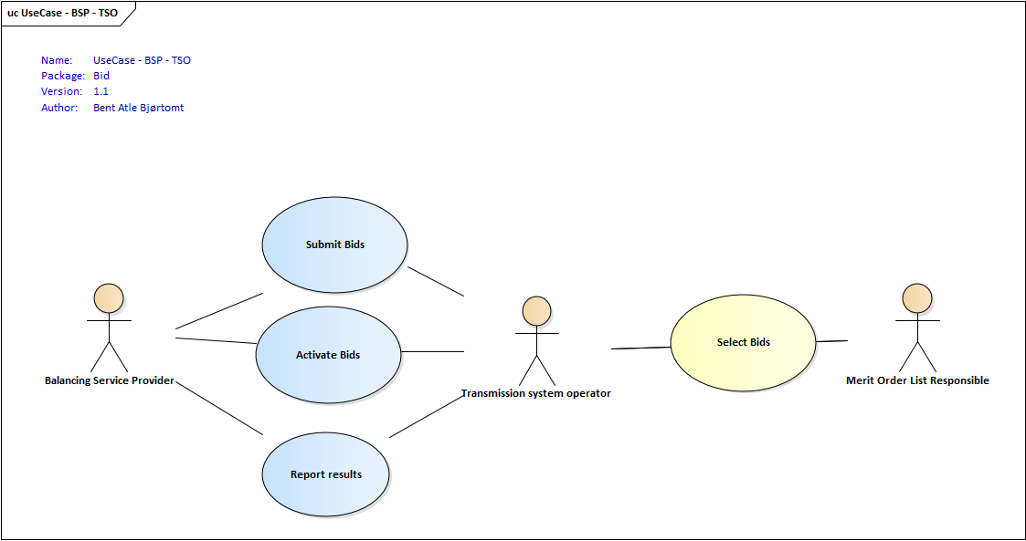

The mFRR energy activation market sequence diagram
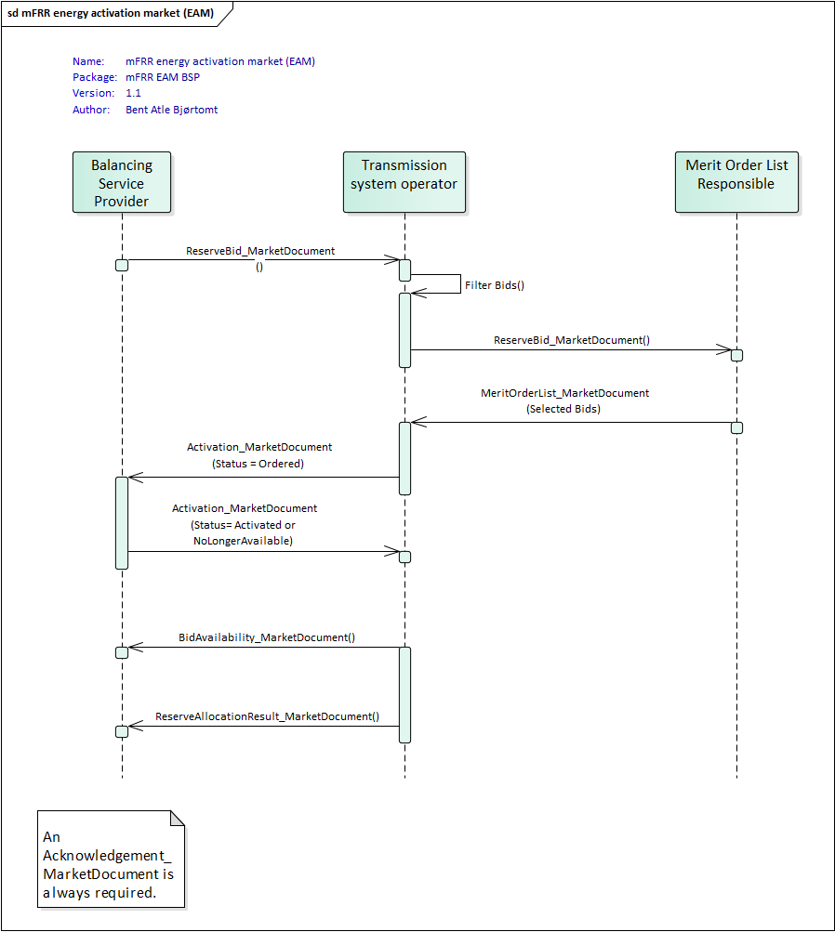
The role "Merit Order List Responsible" will be common Nordic during the steps 1-3 prior to connecting to the European platform MARI step 4.

Submit bid process
Bids can be submitted in a ReserveBid_MarketDocument via the ECP-network provided by the TSO. Alternatively, bids may be submitted via a web user interface, as described in chapter 4. A bid is placed in the market when the TSO has provided a positive Acknowledgement referring to the bid document or a positive confirmation in the web user interface.

Stepwise implementation of product characteristics
On the NBM web-page the Nordic TSOs has published "Memo - Process for activating products". In the memo bid characteristics and bid attributes to be used in the future are described. The content below is based on the table in the memo.
 | Today | Automated operation, pre 15 min ISP (Q4 2022-Q2 2023) | After 15 min ISP but before connection to MARI | When connecting to MARI
Currency | EUR and local currency | EUR | EUR | EUR
Maximum/minimum price (EUR/MWh) | 5000/no minimum price | 5000/no minimum price | 5000/no minimum price | 99 999/-99 999
Price granularity (EUR) | 0.01 or 0.5 | 0.01 or 0.5¹ | 0.01 | 0.01
Minimum bid size (MW) | 5 or 10² | 1 or 10³ | 1 | 1
Maximum bid size (MW) | none or 50 | 9 999  (technical limit) | 9 999  (technical limit) | 9 999  (technical limit)
Bid granularity (MW) | 1 | 1 | 1 | 1
Activation granularity (MW) | 1 | 1 or 0.1⁴ | 1 | 1
BSP bid time resolution for price and volume (minutes). | 60 and 15⁵ | 15 and 60⁶ | 15 | 15
Marginal price resolution (minutes) | 60 | 60 | 15 | 15
¹ Statnett will continue the current practice with 0.5 EUR price granularity from the start of "Automated operation pre 15-min ISP" but foresees to remove this constraint no later than at the introduction of 15 min ISP.
² The minimum bid size differs today depending on the bidding zone.
³ Statnett will continue with a minimum bid volume of 10MW in "Automated operation pre 15-min ISP". Exceptions may apply in some bidding zones or for pilot projects. Also in Sweden some preconditions will apply, see section 4.4.2.
⁴ The normal activation granularity is 1 MW. In cases with multiple divisible bids on the same price as the clearing price the bids will be selected pro rata with activation granularity 0.1 MW.
⁵ In Norway bid volume resolution is 15 min.
⁶ How and when 15-minute bid resolution will be introduced will differ among the TSOs. See chapter 4 for TSO specific information on transition periods and handling of 60-minute resolution.

Attribute descriptions
In this chapter new bid attributes are described. The attributes are either common to all Nordic countries or specific to certain countries. In order to understand and utilize the bid attributes it is useful to define three types of bids:
- Simple bids have one price and are valid for one period. Simple bids are either fully divisible, divisible with a minimum volume or indivisible
- Complex bids are composed of a combination of simple bids for one period. The combination can be either an exclusive group or a multipart bid.
- Linked bids are linked between time periods. E.g. a bid in period 2 is linked to a bid in period 1. The link can be a technical link or a conditional link.
Attributes common for all Nordic countries
The following attributes are MARI standard product attributes that will also be supported by the Nordic AOF from start of automated operation (Q4-2022).
Type | Bid attribute | Description
Simple bids  One bid, one price | Minimum offered volume  CIM:  Point.minimum_Quantity.quantity | Can be applied to set a minimum volume to be activated even though the bid is divisible.
 | Indivisible Bids  CIM:  BidTimeSeries.divisible | A standard mFRR balancing energy product bid, which cannot be activated partially. Therefore, the volume of an indivisible bid is always activated altogether.
Complex bids  Combination of simple bids | Exclusive Group Order  CIM: BidTimeSeries. exclusiveBidsIdentification | The exclusive bid is a group of bids where solely one of the bids can be activated; hence, the activation of a bid belonging to an exclusive bid excludes the activation of the other bids belonging to the same group.
 | Multipart (Parent/child)  CIM: BidTimeSeries.  multipartBidIdentification | A multipart bid consists of two or more simple bids within the same quarter hour. The bids must have different prices but may have the same or different volumes. A component of an upward multipart bid cannot be activated unless all other components with a lower price have been activated up to their entire offered volumes. A component of a downward multipart bid cannot be activated unless all other components with a higher price have been activated up to their entire offered volumes.
Bids linked in time  Between consecutive quarter hours | Conditional bids  CIM: BidTimeSeries.  ConditionalLinkedBids | Conditional linking is the linking of bids (only simple) in two or three subsequent quarter hours. Conditional linking is used to adjust the availability of a bid in QH0 (available/non-available) based on the activation outcome of linked bids in previous quarter hours QH-1 and/or QH-2.
 | Technically linked bids  CIM: BidTimeSeries.  linkedBidsIdentification | Technical linking is the linking of bids (simple or complex) in two or more subsequent quarter hours. Technical linking ensures that a bid in QH0 is not available for clearing if the bid in the previous quarter hour was activated in direct activation (DA). This is important in order not to activate the same balancing resource twice.
Activation type | Direct  CIM: BidTimeSeries.  standard_MarketProduct.  marketProductType | A standard mFRR balancing energy product bid that can be activated at any point of time following the point of scheduled activation of the quarter hour for which the bid is submitted and until the point of scheduled activation of the subsequent quarter hour. Every direct activatable bid is scheduled activatable bid as well.

National bid attributes
See chapter 4 for TSO specific information on which attributes is planned to be implemented and additional information on usage of the bid attributes.
Bid attribute | Description
Maximum duration  CIM: BidTimeSeries. maximum_ConstraintDuration.duration | BSPs include information on the technical limitations regarding how long a bid can be activated. This attribute is necessary to allow BSP to send in bids in advance so that they do not need to update bid if they are activated.  Technical linking of the bids must be in combination with this bid attribute. All the linked bids must have the same maximum duration.
Resting time  CIM: BidTimeSeries. resting_ConstraintDuration.duration | The BSP can add information on the required minimum duration between the end of deactivation and the following activation.  Technical linking of the bids must be in combination with this bid attribute. All the linked bids must have the same resting time.
Inclusive bids  CIM: BidTimeSeries.inclusiveBidsIdentification) | If one bid is activated, another bid (e.g. a resource downstream) must also be activated.
Locational information on bids  CIM: BidTimeSeries.registeredResource.mRID | More detailed location on where the resources in the bid are situated, than bidding zone.
Period shift  CIM: BidTimeSeries.Reason.code | Bids are activated for a shorter period than the whole Market Time Unit around period shift in order to resolve structural imbalances.
Faster activation  CIM: BidTimeSeries. activation_ConstraintDuration.duration | Bids that can support a FAT that is faster than 12,5 minutes.
Slower activation  CIM: BidTimeSeries. activation_ConstraintDuration.duration | Bids that have a FAT that is slower than 12,5 minutes.  During Automated operation pre 15 min ISP, Slower activation bids are only bids that have a FAT that is slower than 15 minutes.

Bid validation rules
Document level
- The bid document must be submitted by the BSP and received by the TSO after the BEGOT and before the BEGCT of every bid in the document.
All bids:
- Bid size min/max and resolution
- Price resolution
- Time period is within the document time period
Exclusive group bid:
- All bid components must have the same activation type
- All bid components must refer to the same market period
- None of the bid components can be part of a multipart bid
Inclusive group bid:
- All bid components must have the same price
- All bid components must be in the same direction
- All bid components must have the same activation type
- All bid components must refer to the same market period
- None of the bid components can be part of an exclusive or multipart bid
Multipart bid:
- All bid components must have different prices
- All bid components must be in the same direction
- All bid components must have the same activation type
- All bid components must refer to the same market period
- None of the bid components can be part of an exclusive bid
Technical linking:
- Technical linking is allowed for both simple bids and for complex bids.
All components of a technically linked complex bid (multipart or exclusive) must have the same value in the linkedBidIdentification attribute.
- Technical linking of simple bids can be used in combination with conditional linking.
- Technical linking ID must be unique within the MTU. That is, within an MTU only one simple bid or one complex bid (with all its bid components) can use a given technical link ID.
Conditional linking:
- Conditional linking is only allowed for simple bids. Both the referenced bids and the referencing bid must be simple.
- A bid in QH0 may be linked to maximum three bids in QH-1 and maximum three bids in QH-2
- It is not permitted to link a given bid in QH0 more than once to a given bid in QH-1 or QH-2
- For each link a condition must be associated
- Conditional bids that try to establish a link to a non-existing bid are not allowed. It is the responsibility of a BSP not to place bids with invalid links. For example, if a BSP cancels a bid, which has other bids linked to that bid, those links will become invalid. Any bid with an invalid link will not be considered in the bid selection.
Other rules:
- A bid cannot be changed from simple bid to complex bid (exclusive, inclusive or multipart). Instead the original bid must be cancelled and a new bid submitted.
- The time period of a bid cannot be changed. If a bid has been submitted with incorrect time period the bid must be cancelled and a new bid (with new bid identification) must be submitted for the correct time period.
- The resource object of a bid cannot be changed. If a bid has been submitted with incorrect resource object the bid must be cancelled and a new bid (with new bid identification) must be submitted for the correct resource object.

See chapter 5.6 for general rules on updating and cancellation of bids.

Bid acknowledgment
Each time a BSP submits a Reserve bid document to the TSO the TSO will return an Acknowledgement document. If all bids in the bid document are valid a positive Acknowledgement will be returned. If one or more of the bids in the bid document are invalid, according to the bid validation rules, a negative Acknowledgment will be returned and all bids in the document will be rejected. The negative Acknowledgement will contain error codes and text that indicate the reason for why the bids are not valid.

Activate bid process
In automated operation, the TSO will send activation orders for selected bids to the respective BSPs every 15 minutes for scheduled activation. Whenever there is a sudden need for activation, the TSO will send activation order for selected bids for direct activation. Scheduled activation orders will cover only one period of 15 minutes. Direct activation orders will cover the remaining of the current 15-minute period and the next 15-minute period.
The activation order must be responded to by the BSP within a certain time limit. The activation process should be automated as much as possible, and ideally fully automated, to avoid timeouts and failed activations.

Activation order
The TSO orders a bid activation by sending the order as a Activation_MarketDocument to the BSP. An activation order may contain activation time series for multiple bids.
The BSP sends an Acknowledgement to the TSO to confirm that the activation order has been received. The Acknowledgement is a confirmation that the activation order has been received.

Activation response
The BSP then sends an activation response to the TSO to confirm that the activation order will be fulfilled, or that it cannot be fulfilled if the resource has become unavailable for activation.
The activation response is sent as an Activation_MarketDocument where the time series are equal to the activation order except for Status and Reason.
The BSP must return the activation response to the TSO within 2 minutes, measured from the time the request is sent from the TSO until the time the response is received by the TSO.
The TSO sends an Acknowledgement to the BSP to confirm that the Activation response has been received. The Acknowledgement will be positive if the Activation response is correct and received within the time limit. Otherwise the Acknowledegement will be negative.

Activation heartbeat
Due to the high criticality of the activation process it is necessary to implement a way to monitor the status of the automated activation process and quickly and accurately detect issues.
The monitoring system is based on periodic heartbeat activations messages. A heartbeat activation is an "empty" activation order that BSPs shall receive, process and respond to like real activation order. The processing of the order should be done by the same systems as for real activation orders. But the heartbeat activation order should not result in any real balancing energy activation.
The BSP should monitor the activation ordering process and correct issues if there is a problem with any of the activation messages (both heartbeats and real orders).
If the BSP does not respond to the heartbeat the TSO may consider the BSP to be unavailable for activation. It is thus important that the BSP responds correctly and timely to both heartbeats and real activation orders.
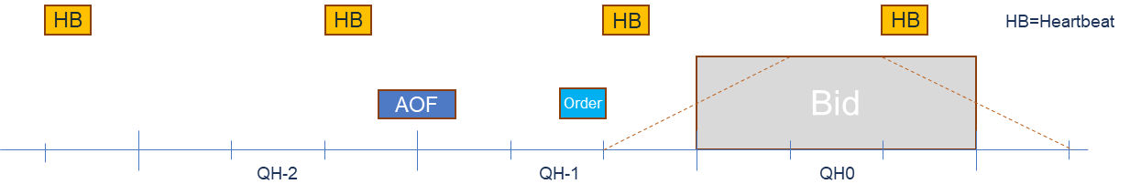
Heartbeat activation order will be sent for every 15-minute period to BSPs who have placed bids in any of the next four 15-minute periods. Additional heartbeat may be sent between periods.
The heartbeat activation order will contain:
- order_ MarketDocument.mRID = unique order id
- A "dummy" time series with
- TimeSeries.mRID = "ACTIVATION_HEARTBEAT"
- acquiring_Domain.mRID = control area (bidding zone for a normal activation)
- registeredResource.mRID = "DUMMY_RESOURCE"
- quantity = 0

Publication and reporting of market results

Publication of market prices and volumes
Market prices and volumes for the mFRR energy activation market will be published on the ENTSO-E Transparency platform (transparency.entsoe.eu) as well as the Nordic Transparency platform NBiS (www.nucs.net).

Activated bids per BSP
A report of each BSP's activated bids will be sent from the TSO to the BSP after each ISP (Imbalance settlement period) in a ReserveAllocationResult_MarketDocument. Please see Appendix 1 for further details on the message document.

Bid availability report
Submitted bids must be available for activation ordering. If bids, for any reason, become unavailable for activation before BEGCT, the BSP must cancel the bids. In cases where bids become unavailable for activation after BEGCT, the BSP must inform the TSO as quickly as possible by phone.
The TSO will for each market period assess the availability of activation for each bid.
The TSO can mark a bid unavailable for the following reasons:
- local congestions
- unavailability of the BSP electronic ordering process
- to meet an activation constraint (max duration and resting time) stated in the bid
The TSO will inform the BSP about bids that have been marked unavailable for activation by sending a BidAvailability_MarketDocument. Please see Appendix 1 for further details on the message document.

TSO specific information

Energinet

Implementation plan
2020
2021
2022
2023
Preparation
Automated operation
Activation
Bid submission
Implementation guide
15 min ISP
Test
Other (availability,
market results)
15 minutes bids in new CIM format
Test
New reports available
15 minutes activations in new CIM format
Test
Health check (heartbeat)
Test

- Bid submission
The BRPs must use the existing bid submission format and 60 minutes resolution until go-live of the new bid submission process in November 2022. After go-live the new CIM format described in this guide and 15 minutes resolution must be used. The new attributes will also be supported from that day. The old format and 60 minutes resolution is no longer supported after go-live.
Testing of the new bid submission process will be possible from beginning of Q2 2022.
- Activation
BRPs will receive activations in the existing format and in 60 minutes resolution until go-live in November 2022. After go-live activations will be in 15 minutes resolution and delivered in the new CIM format described in this guide. Launch of the new activation health check (heart beat) process as well as the change in expected delivery shape – from ramping inside the hour to ramping symmetrically around the quarter hour shifts - will also occur at go-live in November 2022.
Testing of the new activation process will be possible from beginning of Q2 2022.
- Other
After go-live in November 2022 the BRPs will receive the new reports on bid availability and activated bids according to the formats in this guide. By that date the legacy reports for markets results and activated bids will no longer be used.
The new reports will be available for testing from Q3 2022.

Handling of 60 minutes bids in transition period
A transition phase where both 60 minutes and 15 minutes bids can be used simultaneously is currently not planned. 60 minutes bids will be used prior to go-live in November 2022. New CIM format and 15 minute bids will be used after go-live.

Submit bid process

Minimum bid volume
Energinet will allow a minimum bid volume of 1 MW from go-live in November 2022.

National bid attributes
Bid attribute | Planned to be implemented
Maximum duration | To be discussed
Resting time | To be discussed
Inclusive bids | No
Locational information on bids | Yes, optional
Period shift | No
Faster activation | No
Slower activation | Yes

From beginning of automated operation, start- and stop-gradient as well as deadtime for the regulation will no longer be supported.

Communication channel
Communication between BRP and Energinet after go-live in November 2022 is CIM-based and via ECP/EDX.

Fallback for bid submission and/or activation process
From go-live in November 2022 Energinet will introduce the concept of Emergency Volumes. The message flow related to emergency volumes will be further detailed.

Activate bid process
Energinet will allow bids with a FAT slower than the standard product (specified in CIM:activation_ConstraintDuration.duration). The bids with slower activation time will not be forwarded to the AOF, but may be activated locally when circumstances calls for it.

TSO contact information
Any questions and concerns regarding this implementation guide, and the follow-up of the implementation in Energinet, can be directed to: electricitymarket@energinet.dk

Fingrid

Implementation plan
Test
2020
2021
2022
2023
Preparation
Automated operation
Activation
Bid submission
Implementation guide
15 min ISP
Test
Other (availability,
market results)
- - 15 minutes bid in CIM format in use
Test
new reports in use
CIM format in use
- activations every 15 minutes & on demand
60 minutes bids ERRP format can be used

- Bid submission:
BSPs can start using the new bid submission format and the new bid attributes from go-live in November 2022. 15 minutes bid resolution should be used with the new format. Bid submission using the legacy format and 60 minutes bid resolution is possible during the automated operation period. See below for handling of 60 minutes bid resolution. By the end of the automated operation period the legacy format can no longer be used.
Testing of the new bid submission process will be possible from beginning of Q3 2021.
- Activation:
BSPs must start using the formats and process for bid activation described in this guide from go-live in November 2022. The legacy format for bid activation can no longer be used.
- Other:
After go-live in November 2022 the BSPs can start receiving the new reports on bid availability and activated bids according to the formats in this guide.

60 minutes bids in transition period
If BSP sends bids in 60 minutes resolution during the transition period, Fingrid splits a bid into 4 identical bids for each 15 minutes. No new bid attributes can be used for 60 minutes bids. Transformed bids will be fully divisible (and technically linked within the hour). Format for 60 minutes bids is described in a separate implementation guide (Fingrid Implementation Guide mFRR). Activation requests to BSPs are sent separately for every 15 minutes period during the "Automated operation pre 15-minute ISP"-phase.

Submit bid process
The Balancing energy gate opening time (BEGOT) for BSPs is 30 days.

National bid attributes
Bid attribute | Planned to be implemented
Maximum duration | No
Resting time | No
Inclusive bids | No
Locational information on bids | Yes (Locational information will be related to the reserve resources)
Period shift | No
Faster activation | No
Slower activation | No

Alternative channel for bid submission
The preferred channel for bid submission is sending a reserve bid document via ECP. Additionally, bids may be submitted manually in TSO’s MMS (Vaksi Web). More detailed description of manual bid submission can be found in Fingrid's reserve trading and information exchange guidelines (Fingridin reservikaupankäynti- ja tiedonvaihto-ohje). Sending conditionally linked bids will not be possible via Vaksi Web. It is not expected that complex bids can be sent via Vaksi Web.

Activate bid process
TSO may send activation request for system regulation purposes for scheduled activation before T-7.5.

Notification of activation orders via SCADA
A Back-up channel for electronic activation which can be used simultaneously with ECP, is a notification in TSO’s MMS (Vaksi Web) and an alert sent from TSO’s SCADA to the BSP’s SCADA via Elcom. This back-up process requires a manual confirmation in Vaksi Web by the BSP.

TSO contact information
Any questions and concerns regarding this implementation guide, and the follow-up of the implementation in Fingrid, can be directed to: reservit@fingrid.fi

Statnett

Implementation plan
2020
2021
2022
2023
Preparation
Automated operation
Activation
Bid submission
Implementation guide
15 min ISP
Test
Transition
Test
Other (availability,
market results)
Test
Transition

Transition

- Bid submission - Transition:
BSPs can start using the new bid submission format specified in this guide. 15-minute resolution should be used with the new format. Bid submission using the legacy format and 15- or 60-minute resolution is possible during the transition period. See below for handling of 60-minute resolution. By the end of the transition period the legacy format for bid submission can no longer be used.
- Activation – Transition:
BSPs can start using the format for bid activation described in this guide. By the end of the transition period the legacy format for bid activation can no longer be used.
- Other – Transition:
BSPs can start receiving the new reports on bid availability and activated bids according to the formats in this guide. By the end of the transition period the legacy reports for markets results and activated bids will no longer be used.
- For each transition period there will be a test period where the TSO will support end-to-end testing with BSPs.
- Functional verification:
Between transition and start of automated operation, the TSO sees it as beneficial to carry out a functional verification of the new bid attributes to make sure both BSPs and the TSO is ready for the automated operation. Statnett would like to discuss with BSPs how such an end-to-end test with multiple market participants can be carried out and planned for.

Submit bid process

Bid price granularity and minimum bid volume
To limit the number of bids Statnett will continue the current practice with 0.5 EUR price granularity for bid prices. For operational reasons Statnett sees a risk of removing this constraint from the start of Automated operation. Statnett foresees to remove this constraint no later than at the introduction of 15 min ISP.
Statnett will continue with a minimum bid volume of 10MW in the "Automated operation pre 15-minute ISP"-operation. Exceptions may apply in some bidding zones or for pilot projects.

National bid attributes
Bid attribute | Planned to be implemented
Maximum duration | Yes
Resting time | Yes
Inclusive bids | Yes
Locational information on bids | Yes
Period shift | Yes
Faster activation | Yes
Slower activation | No

Alternative channel for bid submission
The recommended method for bid submission is by sending a reserve bid document via ECP. Alternatively, bids may be submitted in the manual user interface FiftyWeb (fiftyweb.statnett.no).

Activate bid process

Faster activation and deactivation
Faster activation and deactivation can be done for bids with activation time (CIM:activation_ConstraintDuration.duration) shorter than the minimum requirement for the standard product. When circumstances call for it, the TSO can order activation of such bids on a shorter notice. See market terms and conditions for description of under what circumstances faster activation and/or deactivation can be used.
For faster activation the TSO will respect the bid's activation time (FAT) and will not request activation or deactivation on shorter notice than the activation time of the bid. For faster activation the preparation time (PT) is 1 minute. The last possible ordering time for faster activation is (FAT–PT)/2+PT minutes before the middle of the ramp.
The TSO can also order faster deactivation of bids, both for standard product bids with 12,5 minutes FAT and faster bids. When ordering earlier deactivation, the TSO will send an updated activation request with the same order identification (order_ MarketDocument.mRID) and the same bid identification for the time series, and where the time period of the activation ends earlier than in the original activation request.
Preparation time of 1 minute and ramping time of 4 minutes is always assumed for faster deactivation. The ordering time for faster deactivation is thus always 3 minutes before the middle of the deactivation ramp.

Period shift activation
Period shift activations will be ordered periodically every 15 minutes based on the amount of structural imbalances around the period shift. All period shift activations for a given quarter hour will be ordered 7,5 minutes before the start of the quarter hour (T-7,5).
Each period shift activation will have a duration of 5 or 10 minutes in either the beginning of the quarter hour or in the end of the quarter hour. The period shift activation will be ordered using an Activation_MarkedDocument.

Legacy period shift handling
The legacy handling of period shift (Produksjonsflytting) will still remain and may be used in circumstances with insufficient availability of bids with support for the new period shift activation. Electronic ordering for legacy handling of period shift will use the codes and rules described in the legacy electronic ordering implementation guide.

No longer supported
The new process for bid activation involves the following simplifications compared to the legacy process:
- The scheme for "recurring activations" is no longer supported.
- Adjustment of activation time period in the activation response from the BSP is no longer supported.

Notification of activation orders via SCADA
The BSP can opt to receive notifications of activation orders via SCADA signalling. A notification signal will then be sent from TSO SCADA to BSP SCADA through ELCOM each time an activation request is sent. Configuration of SCADA to listen for activation signal from TSO SCADA and to provide an acoustic alarm and presentation of the activation notification is required by the BSP.

Alternative channel for activation orders
A notification of activation order will be posted in the FiftyWeb user interface. The BSP can confirm the activation order manually in the FiftyWeb user interface as an alternative to confirmation via ECP. The BSP should monitor ECP activation heartbeat to detect issues with the electronic activation process. In case of issues with the electronic activation process the BSP operator should use FiftyWeb to confirm activation orders.
The described solution will be further evaluated.

TSO contact information
Any questions and concerns regarding this implementation guide, and the follow-up of the implementation in Norway, can be directed to: BSP@statnett.no.

Svenska kraftnät

Implementation plan
2020
2021
2022
2023
Preparation
Automated operation
Activation
Bid submission
Implementation guide
15 min ISP
Test
Transition
Test
Other (availability,
market results)
Test
Transition

Transition

Pilot
- Bid submission - Transition:
BSPs can start using the new bid submission format specified in this guide. 15-minute resolution should be used with the new format. Bid submission using the legacy format and 60-minute resolution is possible during the transition period. See below for handling of 60- minute resolution. By the end of the transition period the legacy format (EDIEL) for bid submission can no longer be used.
- Activation – Transition:
BSPs can start using the format for bid activation described in this guide. By the end of the transition period the legacy format for bid activation can no longer be used.
- Other – Transition:
BSPs can start receiving the new reports on bid availability and activated bids according to the formats in this guide. By the end of the transition period the legacy reports for markets results and activated bids will no longer be used.
- Prior to each transition period there will be a test period where the TSO will support end-to-end testing with BSPs.
- Functional verification:
Between transition and start of automated operation, the TSO sees it as beneficial to carry out a functional verification of the new bid attributes to make sure both BSPs and the TSO is ready for the automated operation. Svenska kraftnät would like to discuss with BSPs how such an end-to-end test with multiple market participants can be carried out and planned for.

Electronic ordering
In due time before the start of Automated operation, all BSPs in Sweden must use electronic ordering. The detailed time plan for this transition will be discussed with BSPs.

Submit bid process

Minimum bid volume
Svk plan to allow minimum bid size of 1 MW from start of automated operation given some preconditions and that operational processes are sufficiently developed. One precondition is that BSPs which intend to lower bid sizes compared to the current thresholds (10 MW in SE1-3 and 5 MW in SE4) make a requalification.

National bid attributes
Bid attribute | Planned to be implemented
Maximum duration | Yes
Resting time | Yes
Inclusive bids | Yes
Locational information on bids | Yes
Period shift | Yes
Faster activation | No
Slower activation | Yes

Alternative channel for bid submission
The recommended method for bid submission is by sending a reserve bid document via ECP. Alternatively, bids may be submitted in the manual user interface FiftyWeb.

Activate bid process

Period shift activation
Period shift activation will be ordered periodically every 15 minutes based on the amount of structural imbalances around the period shift. The period shift activation for beginning of a quarter hour and end of a quarter hour will be ordered 7 minutes before the start of the quarter hour (T-7).
Each period shift activation will have a duration of 5 or 10 minutes. The period shift activation will be ordered using an Activation_MarkedDocument.

Alternative channel for activation orders
A notification of activation order will be posted in the FiftyWeb user interface. The BSP can confirm the activation order manually in the FiftyWeb user interface as an alternative to confirmation via ECP. The BSP should monitor ECP activation heartbeat to detect issues with the electronic activation process. In case of issues with the electronic activation process the BSP operator should use FiftyWeb to confirm activation orders.
The described solution will be further evaluated.

TSO contact information
Any questions and concerns regarding this implementation guide, and the follow-up of the implementation in Sweden, can be directed to: mfrr@svk.se.

General rules for messaging

Date and time
Date and Times are based on ENTSO-E Standards and shall be expressed in universal time (UTC+0) in compliance with ISO 8601 as YYYY-MM-DDThh:mm:ssZ. The last ‘Z’ stands for Zero and indicates UTC+0.

Document coverage
The beginning and ending date and time of the period covered by the document must be on the same CET/CEST day.

Daylight saving time
The day is always expressed in local time, i.e.:
- A day is from 23:00 to 23:00 during winter time.
- A day is from 22:00 to 22:00 during summer time (daylight saving time).
- When changing from winter time to summer time there are 23 hours in the time series (from 23:00 to 22:00).
- When changing from summer time to winter time there are 25 hours in the time series (from 22:00 to 23:00).

Unique identifiers - UUID
Unique identifiers should be proper UUIDs as per RFC 4122 (UUID v1, v4 or v5).

Document identification and revision number
The document identification must be unique over time for the sender in question and should be a proper UUID. The document identification will then not have any significant meaning. The revision number is not used and shall always be equal to '1'.

Update and cancellation principles
To update or cancel time series previously sent a new document is sent with the following information:
- A new unique document mRID (document identification)
- Fixed revision number (always equal to '1')
- A newer created date-time than the previously sent document
For ReserveBid_MarketDocument and Activation_MarketDocument updates can be done by sending only the affected time series with new data. Cancellation of time series is thus done by sending value 0 for quantity.
For BidAvailability_MarketDocument and ReserveAllocationResult_MarketDocument a new document completely replaces a previously sent document for the same period. Cancellation of time series is thus done by omitting the time series in the new document.

Acknowledgment
For each electronic data interchange defined in this document, an acknowledgement document, as defined in IEC 62325-451-1, should be generated either accepting the whole received document or rejecting it completely.
- All received messages shall be validated at both a technical and an application level.
- The Acknowledgement document shall be used as the tool to exchange errors.
- At a technical level, the reason code in the acknowledgement document shall reflect the error type, and the reason text should have a reference to the element containing the error.
- At the application level, the reason code shall reflect the error type and the reason text should reflect the appropriate business rule that is broken.
- An Acknowledgement document may contain many reason objects, to reflect multiple errors in the received document.

Energy communication platform
All the messages described in this document shall be communicated over the Energy communication platform (ECP) provided by each TSO.
Implementation guide for ECP can be requested from the respective TSO.

Appendix 1 – Document attributes and dependencies
This chapter provides the attributes and dependencies for the documents used to support the mFRR energy activation market.

The following classifications are used for the attributes:
- M – Must be used for the document in the process described in this guide
- D – Must be used if a defined condition is met
- O – Optional, can be used

Bid document – Attributes and dependencies
ReserveBid_MarketDocument |  | iec62325-451-7-reservebiddocument.xsd – version 7.2 (available at www.nordicbalancingmodel.net)
mRID | M | Unique identification of the document.  Proper UUID is required.
revisionNumber | M | Constant value of 1
Type | M | A37 - Reserve bid document
process.processType | M | A47 – Manual frequency restoration reserve
sender_MarketParticipant.mRID | M | Identification of the party sending the document  See 6.6 for supported coding schemes.
sender_MarketParticipant.marketRole.type | M | A46 - Balancing Service Provider (BSP)  In Denmark BRPs act as BSP and must use the BSP-role.
receiver_MarketParticipant.mRID | M | Identification of the party receiving the document. One of:  - Energinet.dk  - Fingrid  - Statnett  - Svenska kraftnät
 |  | A01 - EIC coding scheme
receiver_MarketParticipant.marketRole.type | M | A34 – Reserve Allocator
createdDateTime | M | Date and time of document creation (in ISO 8601 UTC format)  YYYY-MM-DDTHH:MM:SSZ
reserveBid_Period.timeInterval | M | The period covered by the document (in ISO 8601 UTC format)  Start: YYYY-MM-DDTHH:MMZ  End: YYYY-MM-DDTHH:MMZ
domain.mRID | M | EIC identification of the Control Area  Denmark: 10Y1001A1001A796  Finland: 10YFI-1--------U  Norway: 10YNO-0--------C  Sweden: 10YSE-1--------K
 |  | A01 - EIC coding scheme
subject_MarketParticipant.mRID | M | Identification of the party responsible for the bid  See 6.6 for supported coding schemes.
subject_MarketParticipant.marketRole.type | M | A46 - Balancing Service Provider (BSP)

BidTimeSeries
mRID | M | Unique identification of the bid.  Proper UUID is required.
auction.mRID | O | Constant value of MFRR_ENERGY_ACTIVATION_MARKET
businessType | M | B74 - Offer
acquiring_Domain.mRID | M | 10Y1001A1001A91G (Nordic Market Area)
 |  | A01 - EIC coding scheme
connecting_Domain.mRID | M | The EIC identification of the bidding zone where the resource is located
 |  | A01 - EIC coding scheme
quantity_Measure_Unit.name | M | MAW – megawatt
currency_Unit.name | M | EUR – euro
price_Measure_Unit.name | R | MAW – megawatt  MWH - Megawatt hours.
Divisible | M | A01 = Yes - quantity may be reduced to the minimum bid size by increments of 1 MW  A02 = No - no reduction possible on the quantity, the bid is indivisible
linkedBidsIdentification | O | Unique identification used to associate technically linked bids. Proper UUID is required.  Not used if bid is not technically linked.
multipartBidsIdentification | O | Unique identification used to associate multipart bids. Proper UUID is required.  If bid with flowDirection.direction=A01 (Up) is accepted, then all associated bids with inferior price must also be accepted. If bid with flowDirection.direction=A02 (Down) is accepted, then all associated bids with superior price must also be accepted.  Not used if bid is not multipart.
exclusiveBidsIdentification | O | Unique identification used to associate exclusive group bids. Proper UUID is required.  If one bid is selected, then none of the other with the same "bid family" identification can be selected.  Not used if bid is not part of exclusive group bid.
inclusiveBidsIdentification | O | Optional for bids in Norway and Sweden.  Unique identification used to associate inclusive group bids. Proper UUID is requireed.  All or none of the bids with the same “bid family” identification must be selected.
Status | M | A06 – Available  For conditionally linked bids, having one or several instances of Linked BidTimeseries:  A65 – Conditionally available  A66 – Conditionally unavailable
registeredResource.mRID | O/M | Mandatory for bids in Finland, Norway and Sweden. Optional in Denmark.  EIC or national code for the resource (regulation object).
flowDirection.direction | M | A01 - Up  A02 - Down
energyPrice_Measure_Unit.name | M | MWH - Megawatt hours.
activation_ConstraintDuration.duration | O | Activation time - The minimum time for full activation of the physical resource including preparation time and ramping time.  For bids that have a standard FAT of 12,5 min (or 15 min in Automated operation) activation time shall be left blank or omitted.  Applicable only to bids in Norway:  For bids that can be activated faster than 12,5 minutes the activation time should be specified and should assume a preparation time of 1 minute.  E.g.  PT3M (if ramping time is 2 min)  PT5M (if ramping time is 4 min)  PT10M (if ramping time is 9 min)  Applicable only to slower activation bids (in Denmark and Sweden):  For bids with slower full activation time than 12,5 minutes (15 minutes in Automated operation) the activation time must be specified.
resting_ConstraintDuration.duration | O | Applicable only to bids in Norway, Sweden, (not yet decided for Denmark):  Resting time for the resource object after an activation, in number of minutes, divisible by 15. E.g.: PT45M, PT60M, PT90M.
maximum_ConstraintDuration.duration | O | Applicable only to bids in Norway, Sweden, (not yet decided for Denmark):  Maximum duration of activation for the resource object, in number of minutes, divisible by 15.  E.g.: PT45M, PT60M, PT90M.  If maximum duration is specified and resting time is not specified, a resting time of 15 minutes will be assumed.
standard_MarketProduct.marketProductType | M | A05 – Standard mFRR product eligible for scheduled activation only  A07 – Standard mFRR product eligible for scheduled and direct activation  A02 – Specific (non-standard) product not eligible for the scheduled or direct activation processes. Must be used for bids with activation time longer than 12,5 min (15 min during Automated operation).  Associated multipart and exclusive bids must have the same value.
Series_Period – exactly one instance per BidTimeSeries
timeInterval | M | Period covered (in ISO 8601 UTC format). Must be 15 or 60 minutes. There must be one, and only one, period for each Bid_TimeSeries.  Start: YYYY-MM-DDTHH:MMZ  End: YYYY-MM-DDTHH:MMZ
Resolution | M | PT15M or PT60M – the time resolution. Must equal the duration of the timeInterval.
Point – exactly one instance per Series_Period
Position | M | Position is always 1
quantity.quantity | M | Offered quantity
energy_Price.amount | M | The price of the product offered
minimum_Quantity.quantity | D | The minimum quantity of energy that can be activated at a given time position  It must be used for divisible bids and can be 0 (fully divisible) but must not be used for indivisible bids.

Linked_BidTimeSeries (associated with BidTimeSeries) - no more than three instances referring to each of MTU-1 and MTU-2, respectively
mRID | O | mRID of a simple bid in MTU-1 or MTU-2
status | D | One of the following values shall be used when bid in MTU0 is conditionally available, i.e. BidTimeSeries.status = A65:  A55 = Not available if linked bid activated  A56 = Not available if linked bid rejected  A59 = Not available if linked bid subject to SA  A60 = Not available if linked bid subject to DA  A57 = Not available for DA if linked bid subject to DA  A58 = Not available for DA if linked bid subject to SA  One of the following values shall be used when bid in MTU0 is conditionally unavailable, i.e. BidTimeSeries.status = A66:  A67 = Available if linked bid activated  A68 = Available if linked bid rejected  A69 = Available if linked bid subject to SA  A70 = Available if linked bid subject to DA  A71 = Available for DA if linked bid subject to DA  A72 = Available for DA if linked bid subject to SA  (SA = scheduled activation, DA = direct activation, MTU = market time unit)  Also see note below.

Reason (associated with BidTimeSeries) – zero, one or two instances per BidTimeSeries
code | O | Optional for bids in Norway and Sweden.  Period shift activation may be ordered.  Z64 = Period shift, beginning of period  Z65 = Period shift, end of period

Rules for evaluation of availability of conditional linked bids:
- A conditionally available bid in MTU0 (i.e. bid with status A65) becomes completely unavailable when at least one of the conditional links indicate unavailability due to the outcome of the linked bid in MTU-1 or MTU-2
- A conditionally available bid in MTU0 becomes unavailable for direct activation when at least one of the conditional links indicate unavailability for direct activation due to the outcome of the linked bid in MTU-1 or MTU-2
- A conditionally unavailable bid in MTU0 (i.e. bid with status A66) becomes available when at least one of the conditional links indicate availability due to the outcome of the linked bid in MTU-1 or MTU-2
- A conditionally unavailable bid in MTU0 becomes available for direct activation when at least one of the conditional links indicate availability for direct activation due to the outcome of the linked bid in MTU-1 or MTU-2.

ReserveBid_MarketDocument assembly model
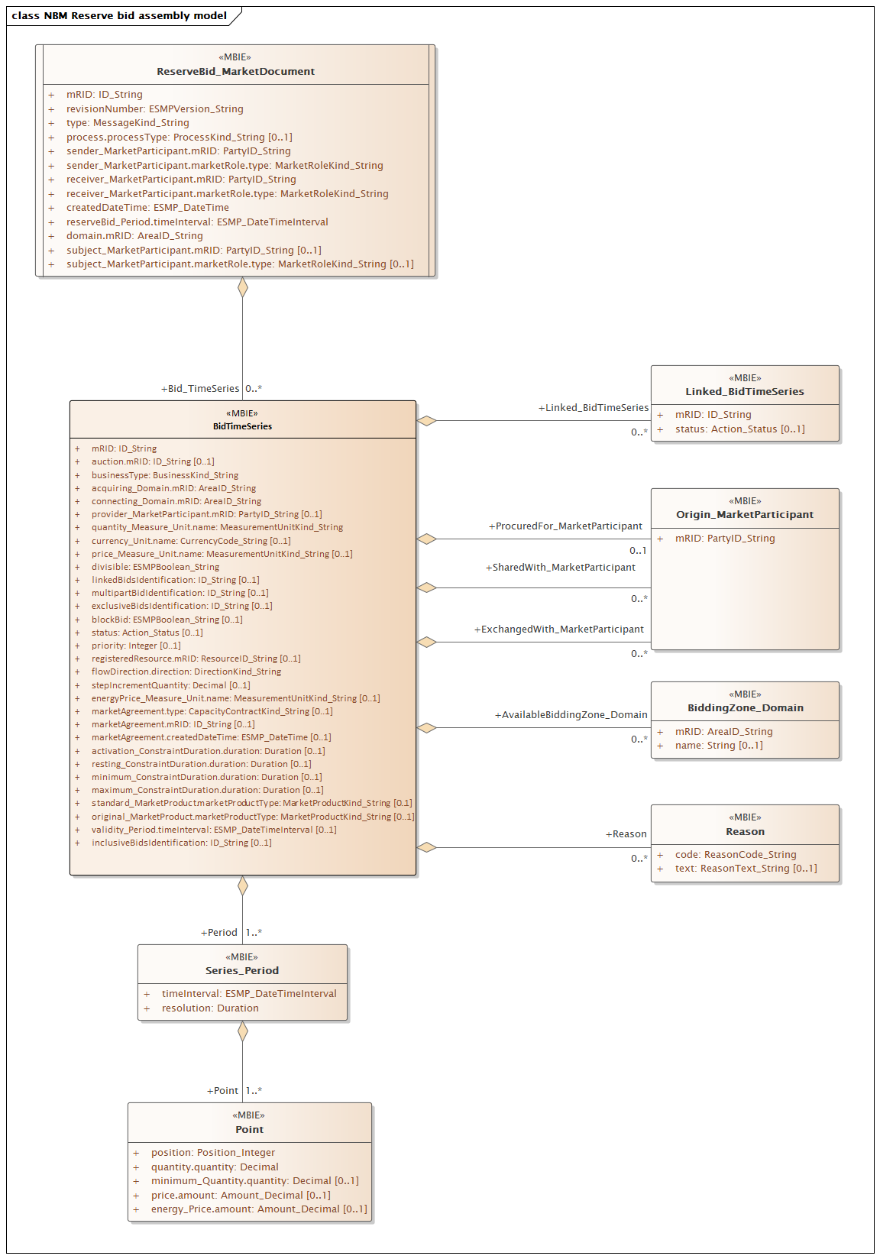
Note: the cardinalities indicated in the assembly model are further restricted for the implementation according to this guide, please see Attributes and dependencies table above.

Activation document – Attributes and dependencies
Activation_MarketDocument |  | iec62325-451-7-activationdocument – version 6.1
mRID | M | Unique identification of the document. Proper UUID is required.
revisionNumber | M | Constant value of 1
Type | M | For the request:  A39 – SATCR activation (Scheduled activation)  A40 – DATCR activation (Direct activation)  Z37 – Faster than standard FAT  Z38 – Faster than standard deactivation time  Z39– Slower than standard FAT  Z40 – Period shift activation  For the response:  A41 – Activation response
process.processType | M | A47 – Manual frequency restoration reserve
sender_MarketParticipant.mRID | M | Identification of the party sending the document  See 6.6 for supported coding schemes.
sender_MarketParticipant.marketRole.type | M | For the request:  A04 – System Operator  For the response:  A46 – Balancing Service Provider (BSP)  A27 – Resource Provider
receiver_MarketParticipant.mRID | M | Identification of the party receiving the document.  See 6.6 for supported coding schemes.
receiver_MarketParticipant.marketRole.type | M | For the request:  A46 – Balancing Service Provider (BSP)  A27 – Resource Provider  For the response:  A04 – System Operator
createdDateTime | M | Date and time of document creation (in ISO 8601 UTC format)  YYYY-MM-DDTHH:MM:SSZ
activation_Time_Period.timeInterval | M | The period covered by the document (in ISO 8601 UTC format)  Start: YYYY-MM-DDTHH:MMZ  End: YYYY-MM-DDTHH:MMZ  ---  1 MTU (Market Unit Time – 15 min) for Scheduled activation (SA).  2 MTUs ( 30 min.) for Direct activation (DA).
domain.mRID | M | EIC identification of the Control Area  Denmark (DK1): 10YDK-1--------W  Denmark (DK2): 10YDK-2--------M  Finland: 10YFI-1--------U  Norway: 10YNO-0--------C  Sweden: 10YSE-1--------K
 |  | A01 - EIC coding scheme
subject_MarketParticipant.mRID | M | Identification of the party for whom the bid document is submitted.  See 6.6 for supported coding schemes.
subject_MarketParticipant.marketRole.type | M | A46 – Balancing Service Provider (BSP)
order_ MarketDocument.mRID | M | Unique identification of the activation order. The same order id is used in the request and the response. UUID.
order_MarketDocument.revisonNumber | M | The version of the activation order. Incremented with one for each transmission of the document from the System Operator. The same version is used in the request and the response.
TimeSeries – one or more instances
mRID | M | Reference to the bid to be activated. Proper UUID is required.
resourceProvider_MarketParticipant.mRID | M | The identification of the Resource Provider.
businessType | M | A97 – Manual frequency restoration reserve
acquiring_Domain.mRID | M | The EIC identification of the Nordic Market Area - 10Y1001A1001A91G
 |  | A01 – EIC coding scheme
connecting_Domain.mRID | M | The EIC identification of the bidding zone where the resource is located (repeat from Acquiring Area)
 |  | A01 – EIC coding scheme
meaurement_Unit.name | M | MAW – megawatt
flowDirection.direction | M | A01 – Up  A02 – Down
marketObjectStatus.status | M | Only in the request:  A10 – Ordered  Only in the response:  A07 – Activated (confirmation that quantities in the time series have been activated)  A11 – Unavailable
registeredResource.mRID | O/M | EIC or national code for the resource (regulation object).
Series_Period – exactly one instance per TimeSeries
timeInterval | M | The start and end date and time of the time interval of the period of activation.
resolution | M | The time resolution is always the difference between the Time Interval End and the Time Interval Start.
Point – exactly one instance per Series_Period
position | M | Position is always 1
quantity.quantity | M | Activated quantity
Reason
code | M | B22 – System regulation  B49 – Balancing
text | O

Activation_MarketDocument assembly model
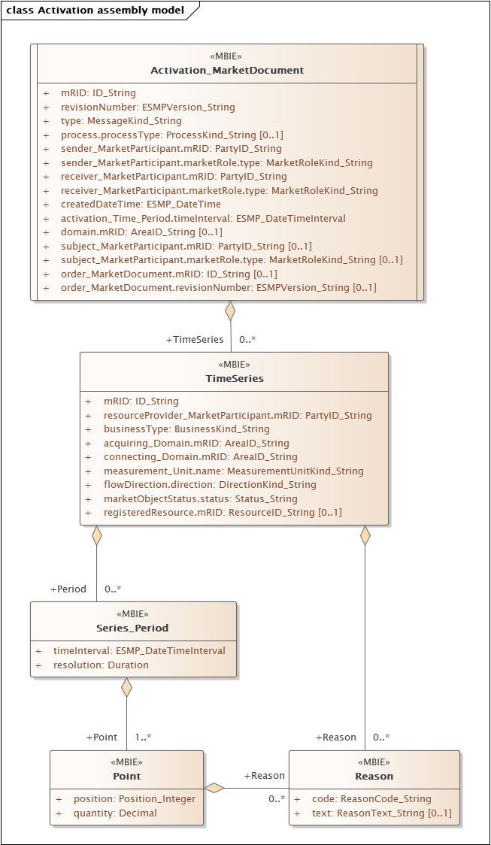
Note: the cardinalities indicated in the assembly model are further restricted for the implementation according to this guide, please see Attributes and dependencies table above.

Bid availability document – Attributes and dependencies
BidAvailability_MarketDocument |  | urn:iec62325.351:tc57wg16:451-n:bidavailabilitydocument:1:0
mRID | M | Unique identification of the document.  Proper UUID is required.
revisionNumber | M | Constant value of 1
Type | M | B45 – Bid availability document
process.processType | M | A47 – Manual frequency restoration reserve
sender_MarketParticipant.mRID | M | Identification of the party sending the document. One of:  - Energinet.dk  - Fingrid  - Statnett  - Svenska kraftnät
 |  | A01 – EIC coding scheme
sender_MarketParticipant.marketRole.type | M | A04 – System Operator
receiver_MarketParticipant.mRID | M | Identification of the party receiving the document.  See 6.6 for supported coding schemes.
receiver_MarketParticipant.marketRole.type | M | A46 – Balancing Service Provider (BSP)
createdDateTime | M | Date and time of document creation (in ISO 8601 UTC format)  YYYY-MM-DDTHH:MM:SSZ
reserveBid_Period.timeInterval | M | The period(s) covered by the bid(s) referenced in the document (in ISO 8601 UTC format)  Start: YYYY-MM-DDTHH:MMZ  End: YYYY-MM-DDTHH:MMZ
BidTimeSeries – one or more instances
mRID | M | Unique identification of the bid
bidDocument_MarketDocument.mRID | M | Constant value of NA
bidDocument_MarketDocument.revisionNumber | M | Constant value of 1
requestingParty_MarketParticipant.mRID | M | EIC code of Party that requested the update of bid availability
requestingParty_MarketParticipant.marketRole.type | M | A46 – Balancing Service Provider  A49 – Transmission System Operator  A50 – Distribution System Operator
businessType | M | C40 – Conditional bid  C41 – Thermal limit  C42 – Frequency limit  C43 – Voltage limit  C44 – Current limit  C45 – Short-circuit current limits  C46 – Dynamic stability limit
acquiring_Domain.mRID | M | The EIC identification of the Nordic Market Area - 10Y1001A1001A91G
 |  | A01 – EIC coding scheme
domain.mRID | M | The EIC identification of the bidding zone where the resource is located
 |  | A01 – EIC coding scheme
Reason – exactly one instance per time series *)
Code | M | When business type = C40 the following reasons apply:  B16 = Tender unavailable in MOL list  When business type = C42 one of the following reasons apply:  B58 – Insufficiency of reserves  B59 – Unavailability of reserve providing units  When business type = C41, C43, C44, C45 or C46 one of the following reasons apply:  B18 – Failure  B46 – Internal congestion  B47 – Operational security constraints  B60 – Unavailability of automatic protection systems
text | O | May be populated to provide additional explanation in free text format
RegisteredResource (associated with BidTimeSeries) – only when BusinessType is Thermal Limit = C41
mrID | O | EIC code of concerned network element

*) The business types and reasons can be subject to changes to do the development of the MARI-project.

BidAvailability_MarketDocument assembly model
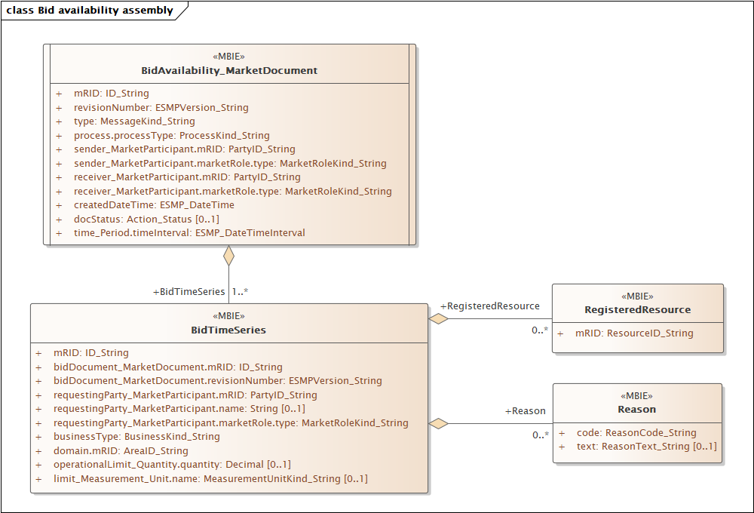
Note: This is the MARI definition. The cardinalities indicated in the assembly model are further restricted for the implementation according to this guide, please see Attributes and dependencies table above.

Reserve allocation result document – Attributes and dependencies
ReserveAllocationResult_MarketDocument |  | iec62325-451-7-reserveallocationresult.xsd –version 6.0
mRID | M | Unique identification of the document. Proper UUID is required.
revisionNumber | M | Constant value of 1
Type | M | A38 – Reserve allocation result document
process.processType | M | A47 – Manual frequency restoration reserve
sender_MarketParticipant.mRID | M | Identification of the party sending the document. One of:  - Energinet.dk  - Fingrid  - Statnett  - Svenska kraftnät
 |  | A01 – EIC
sender_MarketParticipant.marketRole.type | M | A04 – System Operator
receiver_MarketParticipant.mRID | M | Identification of the party receiving the document.  See 6.6 for supported coding schemes.
receiver_MarketParticipant.marketRole.type | M | A46 – Balancing Service Provider (BSP)
createdDateTime | M | Date and time of document creation (in ISO 8601 UTC format)  YYYY-MM-DDTHH:MM:SSZ
reserveBid_Period.timeInterval | M | The period covered by the document (in ISO 8601 UTC format)  Start: YYYY-MM-DDTHH:MMZ  End: YYYY-MM-DDTHH:MMZ  ---  1 MTU (Market Unit Time – 15 min) for Scheduled activation (SA).  2 MTUs ( 30 min.) for Direct activation (DA).
domain.mRID | M | EIC identification of the Control Area  Denmark (DK1): 10YDK-1--------W  Denmark (DK2): 10YDK-2--------M  Finland: 10YFI-1--------U  Norway: 10YNO-0--------C  Sweden: 10YSE-1--------K
 |  | A01 – EIC coding scheme
TimeSeries – one or more instances
mRID | M | Unique identification of the time series
bid_Original_MarketDocument.mRID | M | Constant value of NA
bid_Original_MarketDocument.revisionNumber | M | Constant value of 1
bid_Original_MarketDocument.bid_TimeSeries.mRID | M | Reference to the bid (unique bid identification)
bid_Original_MarketDocument.  tendering_MarketParticipant.mRID | M | Identification of the tendering party (BSP) according to the original bid document.
auction.mRID |  | Constant value of MFRR_ENERGY_ACTIVATION_MARKET
businessType | M | A97 – Manual frequency restoration reserve
acquiring_Domain.mRID | M | The EIC identification of the Nordic Market Area - 10Y1001A1001A91G
 |  | A01 – EIC coding scheme
connecting_Domain.mRID | M | The EIC identification of the bidding zone where the resource is located (repeat from Acquiring Area)
 |  | A01 – EIC coding scheme
marketAgreement.type | M | Constant value of "NA"
marketAgreement.mrID | M | Constant value of "NA"
meaurementquantity_Meaure_Unit.name | M | MAW – megawatt
currency_Unit.name | M | EUR – euro
energyPrice_Measure_Unit.name | M | MWH - Megawatt hours
flowDirection.direction | M | A01 – Up  A02 – Down
Series_Period – exactly one instance per TimeSeries
timeInterval | M | The start and end date and time of the time interval of the period of activation.
resolution | M | The time resolution is always the difference between the Time Interval End and the Time Interval Start.
Point – exactly one instance per Series_Period
position | M | Position is always 1
quantity.quantity | M | Activated quantity  The agreed delivery. Will be 0 for bids not activated.
Reason
code | M | B22 – System regulation  B49 – Balancing  Z58 – Scheduled activation  Z59 – Direct activation  Z60 – Faster than standard FAT  Z61 – Faster than standard deactivation  Z62 – Slower than standard FAT  Z63 – Period shift activation
text | O | May be populated to provide additional explanation in free text format

ReserveAllocationResult_MarketDocument assembly model
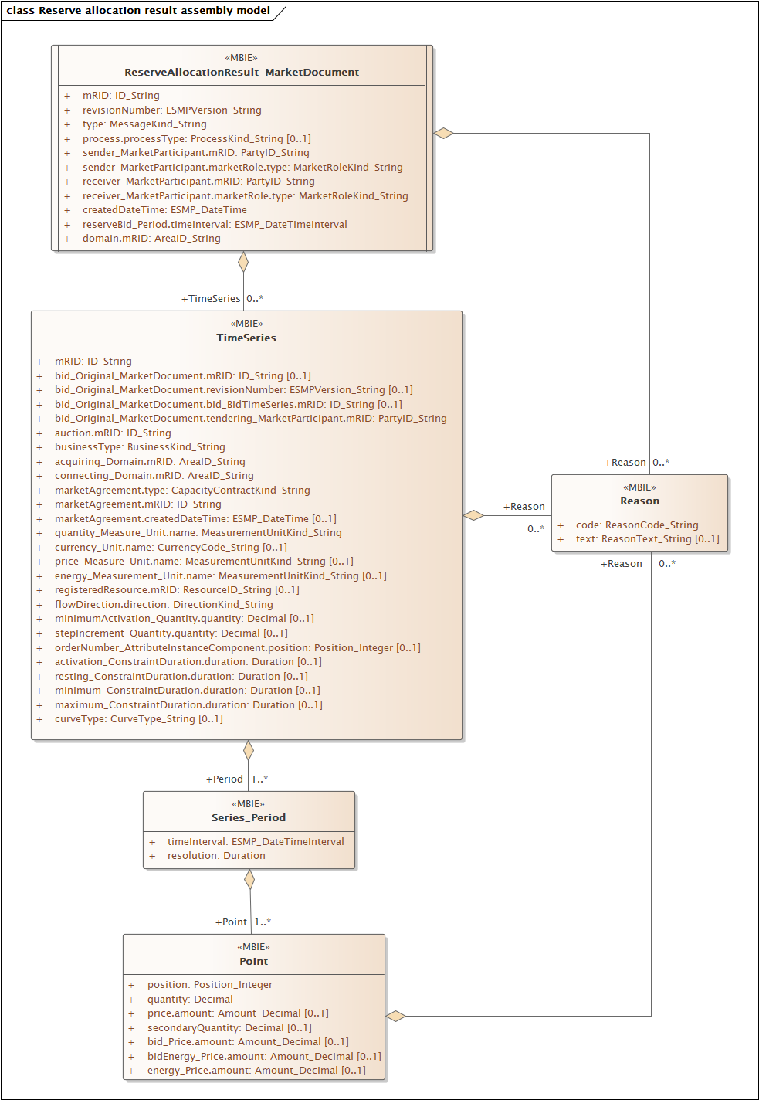
Note: the cardinalities indicated in the assembly model are further restricted for the implementation according to this guide, please see Attributes and dependencies table above.

Acknowledgement document – Attributes and dependencies
Acknowlegdement_MarketDocument |  | iec62325-451-1-acknowledgement.xsd –version 8.1
mRID | M | Unique identification of the document.
createdDateTime | M | Date and time of document creation (in ISO 8601 UTC format)  YYYY-MM-DDTHH:MM:SSZ
sender_MarketParticipant.mRID | M | Identification of the party sending the document.  See 6.6 for supported coding schemes.
sender_MarketParticipant.marketRole.type | M | One of:  A04 – System Operator  A46 – Balancing Service Provider (BSP)  A27 – Resource Provider  A34 – Reserve Allocator
receiver_MarketParticipant.mRID | M | Identification of the party receiving the document.  See 6.6 for supported coding schemes.
receiver_MarketParticipant.marketRole.type | M | One of:  A04 – System Operator  A46 – Balancing Service Provider (BSP)  A27 – Resource Provider
received_MarketDocument.mRID | M | The unique identification of the received document.
received_MarketDocument.revisionNumber | M | The revision of the received document.
received_MarketDocument.type | M | The type of the received document.
received_MarketDocument.process.processType | M | The processType of the received document.
received_MarketDocument.createdDateTime | M | The date and time of the creation of the received document.
Reason – one or more instances
code | M | A01 – Message fully accepted  A02 – Message fully rejected  More specific error codes may be used.
text | O | May be populated to provide additional explanation in free text format.

Reason – zero or more instances per time series
code | M | 999 – Errors not specifically identified  More specific error codes may be used.
text | O | May be populated to provide additional explanation in free text format.  For rejected bids a specific reason for the rejection will be provided.

Supported coding schemes for sender/receiver identification
The following coding schemes are supported for identification of sender/receiver.
A01 – EIC
A10 – GS1
NSE – Swedish national coding scheme
NFI – Finnish national coding scheme. It will be decided in the autumn 2021 whether NFI will still be supported.

Appendix 2 – Examples
Simple bid:
<ReserveBid_MarketDocument xmlns="urn:iec62325.351:tc57wg16:451-7:reservebiddocument:7:2">
<mRID>a1969da3-b329-4b22-ad85-206242ff5953</mRID>
<revisionNumber>1</revisionNumber>
<type>A37</type>
<process.processType>A47</process.processType>
<sender_MarketParticipant.mRID codingScheme="A01">10X1001A1001A38Y</sender_MarketParticipant.mRID>
<sender_MarketParticipant.marketRole.type>A04</sender_MarketParticipant.marketRole.type>
<receiver_MarketParticipant.mRID codingScheme="A01">10V1001C--000284</receiver_MarketParticipant.mRID>
<receiver_MarketParticipant.marketRole.type>A35</receiver_MarketParticipant.marketRole.type>
<createdDateTime>2020-09-22T12:45:37Z</createdDateTime>
<reserveBid_Period.timeInterval>
<start>2020-09-22T13:15Z</start>
<end>2020-09-22T13:30Z</end>
</reserveBid_Period.timeInterval>
<domain.mRID codingScheme="A01">10Y1001A1001A91G</domain.mRID>
<subject_MarketParticipant.mRID codingScheme="A01">10X1001A1001A38Y</subject_MarketParticipant.mRID>
<subject_MarketParticipant.marketRole.type>A27</subject_MarketParticipant.marketRole.type>
<Bid_TimeSeries>
<mRID>921f1eda-0709-410c-9f2e-1a9aad03a191</mRID>
<auction.mRID>MFRR_ENERGY_ACTIVATION_MARKET</auction.mRID>
<businessType>B74</businessType>
<acquiring_Domain.mRID codingScheme="A01">10Y1001A1001A91G</acquiring_Domain.mRID>
<connecting_Domain.mRID codingScheme="A01">10YNO-1--------2</connecting_Domain.mRID>
<quantity_Measure_Unit.name>MAW</quantity_Measure_Unit.name>
<currency_Unit.name>EUR</currency_Unit.name>
<price_Measure_Unit.name>MWH</price_Measure_Unit.name>
<divisible>A01</divisible>
<flowDirection.direction>A01</flowDirection.direction>
<energyPrice_Measure_Unit.name>MWH</energyPrice_Measure_Unit.name>
<standard_MarketProduct.marketProductType>A02</standard_MarketProduct.marketProductType>
<original_MarketProduct.marketProductType>A02</original_MarketProduct.marketProductType>
<Period>
<timeInterval>
<start>2020-09-22T13:15Z</start>
<end>2020-09-22T13:30Z</end>
</timeInterval>
<resolution>PT15M</resolution>
<Point>
<position>1</position>
<quantity.quantity>5</quantity.quantity>
<minimum_Quantity.quantity>0</minimum_Quantity.quantity>
<price.amount>99.26</price.amount>
</Point>
</Period>
</Bid_TimeSeries>
</ReserveBid_MarketDocument>

Activation order:
<Activation_MarketDocument xmlns="urn:iec62325.351:tc57wg16:451-7:activationdocument:6:1">
<mRID>de5e8c7d-d539-41f5-9618-7249a8ee5ee1</mRID>
<revisionNumber>1</revisionNumber>
<type>A39</type>
<process.processType>A47</process.processType>
<sender_MarketParticipant.mRID codingScheme="A01">10X1001A1001A329</sender_MarketParticipant.mRID>
<sender_MarketParticipant.marketRole.type>A04</sender_MarketParticipant.marketRole.type>
<receiver_MarketParticipant.mRID codingScheme="A01">17X100Z100Z0001H </receiver_MarketParticipant.mRID>
<receiver_MarketParticipant.marketRole.type>A46</receiver_MarketParticipant.marketRole.type>
<createdDateTime>2020-11-12T00:21:04Z</createdDateTime>
<activation_Time_Period.timeInterval>
<start>2020-11-12T01:00Z</start>
<end>2020-11-12T01:15Z</end>
</activation_Time_Period.timeInterval>
<domain.mRID codingScheme="A01">10YDOM-1001A001A</domain.mRID>
<subject_MarketParticipant.mRID codingScheme="A01">17X100Z100Z0001H</subject_MarketParticipant.mRID>
<subject_MarketParticipant.marketRole.type>A46</subject_MarketParticipant.marketRole.type>
<order_MarketDocument.mRID>fdd258d4-7a96-44fe-bcb1-ca9fa5dc8804</order_MarketDocument.mRID>
<order_MarketDocument.revisionNumber>1</order_MarketDocument.revisionNumber>
<TimeSeries>
<mRID>921f1eda-0709-410c-9f2e-1a9aad03a191</mRID>
<resourceProvider_MarketParticipant.mRID codingScheme="A01">50WG00000002488C</resourceProvider_MarketParticipant.mRID>
<businessType>A97</businessType>
<acquiring_Domain.mRID codingScheme="A01">10Y1001A1001A91G</acquiring_Domain.mRID>
<connecting_Domain.mRID codingScheme="A01">10YPT-REN------W</connecting_Domain.mRID>
<measurement_Unit.name>MAW </measurement_Unit.name>
<flowDirection.direction>A01</flowDirection.direction>
<marketObjectStatus.status>A10</marketObjectStatus.status>
<registeredResource.mRID codingScheme="A01">10XPT-REN------9</registeredResource.mRID>
<Period>
<timeInterval>
<start>2013-11-12T01:00Z</start>
<end>2013-11-12T01:15Z</end>
</timeInterval>
<resolution>PT15M</resolution>
<Point>
<position>1</position>
<quantity>1500</quantity>
</Point>
</Period>
<Reason>
<code>B49</code>
</Reason>
</TimeSeries>
</Activation_MarketDocument>

Activation response:
<Activation_MarketDocument xmlns = "urn:iec62325.351:tc57wg16:451-7:activationdocument:6:1">
<mRID>e6aff3c8-5310-4c2e-a1ba-06aded3e7c21</mRID>
<revisionNumber>1</revisionNumber>
<type>A41</type>
<process.processType>A47</process.processType>
<sender_MarketParticipant.mRID codingScheme = "A01">17X100Z100Z0001H</sender_MarketParticipant.mRID>
<sender_MarketParticipant.marketRole.type>A46</sender_MarketParticipant.marketRole.type>
<receiver_MarketParticipant.mRID codingScheme = "A01">10X1001A1001A329</receiver_MarketParticipant.mRID>
<receiver_MarketParticipant.marketRole.type>A04</receiver_MarketParticipant.marketRole.type>
<createdDateTime>2020-11-12T00:21:09Z</createdDateTime>
<activation_Time_Period.timeInterval>
<start>2020-11-12T01:00Z</start>
<end>2020-11-12T01:15Z</end>
</activation_Time_Period.timeInterval>
<domain.mRID codingScheme = "A01">10YDOM-1001A001A</domain.mRID>
<order_MarketDocument.mRID>fdd258d4-7a96-44fe-bcb1-ca9fa5dc8804</order_MarketDocument.mRID>
<order_MarketDocument.revisionNumber>1</order_MarketDocument.revisionNumber>
<TimeSeries>
<mRID>921f1eda-0709-410c-9f2e-1a9aad03a191</mRID>
<resourceProvider_MarketParticipant.mRID codingScheme = "A01">50WG00000002488C</resourceProvider_MarketParticipant.mRID>
<businessType>A97</businessType>
<acquiring_Domain.mRID codingScheme = "A01">10Y1001A1001A91G</acquiring_Domain.mRID>
<connecting_Domain.mRID codingScheme = "A01">10YPT-REN------W</connecting_Domain.mRID>
<measurement_Unit.name>MAW</measurement_Unit.name>
<flowDirection.direction>A01</flowDirection.direction>
<marketObjectStatus.status>A07</marketObjectStatus.status>
<registeredResource.mRID codingScheme="A01">10XPT-REN------9</registeredResource.mRID>
<Period>
<timeInterval>
<start>2020-11-12T01:00Z</start>
<end>2020-11-12T01:15Z</end>
</timeInterval>
<resolution>PT15M</resolution>
<Point>
<position>1</position>
<quantity>1500</quantity>
</Point>
</Period>
</TimeSeries>
</Activation_MarketDocument>

In Denmark the BSP role has not been separated from the BRP role, so in Denmark the target ordience for this document is the BRP. Whenever the term BSP is used thoroughout this document it should be interpreted - for Denmark - as the «BRP acting as BSP»
User guide for the legacy format (EDIEL) is available at ediel.no/Info/bruker-og-implementasjonsguider
Available at ediel.no/Info/bruker-og-implementasjonsguider ("Implementation guide – TCR Activation")

